Quantum Secure Messaging Protocol – QSMP

Revision 1a, July 31, 2021

John G. Underhill – john.underhill@protonmail.com

This document is an engineering level description of the QSMP encrypted and authenticated network messaging protocol.

In its contents, a guide to implementing QSMP, an explanation of its design, links to a C reference implementation, as well as references to its component primitives and links to supporting documentation.

**Contents Page**

Foreword 2

1: Figures 3

2: Tables 4

3: Introduction 5

2: Scope 7

3: References 8

4: Terms and definitions 9

5: Structures 10

6: Operational Overview 16

7: Formal Description 30

8: Design Decisions 38

# **Foreword**

This document is intended as the preliminary draft of a new standards proposal, and as a basis from which that standard can be implemented. We intend that this serve as an explanation of this new technology, and as a complete description of the protocol.

This document is the first revision of the specification of QSMP, further revisions may become necessary during the pursuit of a standard model, and revision numbers shall be incremented with changes to the specification. The reader is asked to consider only the most recent revision of this draft, as the authoritative expression of the QSMP specification.

Future revisions of this standards draft can be found at: https://github.com/Steppenwolfe65/QSMP

The author of this specification is John G. Underhill, and can be reached at john.underhill@protonmail.com

QSMP, the algorithm constituting the QSMP messaging protocol is patent pending, and is owned by John G. Underhill and Digital Freedom Defense Incorporated. The code described herein is copyrighted, and owned by John G. Underhill and Digital Freedom Defense Incorporated.

**Figures**

**Contents Page**

Figure 6.1: Key-Exchange Connect Request 12

Figure 6.2: Key-Exchange Connect Response 13

Figure 6.3: Key-Exchange ExStart Request 14

Figure 6.4: Key-Exchange ExStart Response 15

Figure 6.5: Key-Exchange Exchange Request 15

Figure 6.6: Key-Exchange Exchange Response 15

Figure 6.7: Key-Exchange Establish Request 16

Figure 6.8: Key-Exchange Establish Response 16

Figure 6.9: Key-Exchange Verify 16

# **Tables**

**Contents Page**

Table 5.1: The Protocol string choices in revision 1a. 10

Table 5.4a: Packet header message types 10

Table 5.2: The client key structure 11

Table 5.3: The server key structure 11

Table 5.4: The client state structure. 12

Table 5.5: The server state structure 12

Table 5.6: The keep alive state 13

Table 5.7: The QSMP packet structure 13

Table 5.8: Packet header flag types 14

Table 5.9: Error type messages 14

# **1 Introduction**

The Secure Shell protocol (SSH), was designed as a secure replacement for Telnet, RSH, and other unsecured remote shell applications. SSH has several different encryption and key exchange methods; it can use a fixed shared symmetric key, a fixed asymmetric public/private cipher key, or a Diffie-Hellman key exchange. SSH is not limited to remote shell applications, it is used extensively as a mechanism for establishing a secure connection between remote hosts. It is employed to establish a secure channel for encrypted tunneling, VPNs, encrypted proxies, remote filesystems, secure file transfer, and commodity trading applications. QSMP has been designed to be a stronger, safer, post-quantum alternative to SSH.

QSMP is a quantum secure messaging protocol, that employs state of the art asymmetric ciphers and signature schemes, and a post-quantum strength symmetric cipher. The current incarnation can use the Kyber, NTRU, or McEliece asymmetric ciphers, and the Dilithium or Sphincs+ signature schemes, the leading round 3 candidates in the NIST Post Quantum competition. It uses the authenticated symmetric stream cipher RCS, based on the Rijndael-256 cipher, with increased rounds, a cryptographically strong key-schedule, and AEAD authentication using KMAC. QSMP was designed to be more flexible and more secure than the SSH protocol, and can be used in any context where strong post-quantum security is required in a client/server communications stream.

* 1. **Purpose**

The QSMP secure messaging protocol, utilized in conjunction with quantum secure asymmetric and symmetric cryptographic primitives, is used to create an encrypted and authenticated bi-directional communications channel. This specification presents a secure messaging protocol that creates an encrypted and duplexed communications channel, in such a way that:

1. The asymmetric cipher keys for both the send and receive channels, are ephemeral, and encapsulate shared secrets for each channel that are also unique to each channel and session (forward secrecy).
2. The capture of the shared keys does not reveal any information about future sessions (predicative resistance).
3. That each host in the bi-directional communications stream, is responsible for creating the shared secret for the channel they transmit on.

QSMP is a two-channel duplexed communications system. It uses a separate shared secret to key both the transmit and receive channels in a communications stream. Each host is responsible for generating and encapsulating the symmetric key that host transmits data on. Asymmetric cipher keys are ephemeral, and unique symmetric cipher keys are generated for each channel and session. The system works in a client/server model, where a client requests a connection from the server to initiate the key exchange. The server signs the asymmetric encapsulation key sent to the client, and the client uses a MAC function to authenticate the asymmetric encapsulation key sent to the server. The signature algorithm is quantum secure, and the public verification key can be signed using the X509 hierarchal signature scheme, to create a ‘chain of trust’. A strong emphasis has been placed on authentication with QSMP, with the entire key exchange using authentication to guarantee the exchange, as well as the symmetric stream cipher that uses strong symmetric message authentication.

# **Scope**

This document describes the QSMP secure messaging protocol, which is used to establish an encrypted and authenticated duplexed communications channel between two hosts. This document describes the complete asymmetric key exchange, authentication, and the establishment of a secure network communications stream. This is a complete specification, describing the cryptographic primitives, the key derivation functions, and the complete client to server messaging paradigm.

Test vectors and C reference code will be available at https://github.com/Steppenwolfe65/QSMP

**2.1 Application**

This protocol is intended for institutions that implement secure communication channels used to encrypt and authenticate secret information exchanged between remote terminals.

The key exchange functions, authentication and encryption of messages, and message exchanges between terminals defined in this document must be considered as mandatory elements in the construction of an QSMP communications stream. Components that are not necessarily mandatory, but are the recommended settings or usage of the protocol shall be denoted by the key-words **SHOULD**. In circumstances where strict conformance to implementation procedures are required but not necessarily obvious, the key-word **SHALL** will be used to indicate compulsory compliance is required to conform to the specification.

## **References**

**3.1 Normative References**

The following documents serve as references for key components of QSMP:

1. NIST FIPS 202: SHA-3 Standard: Permutation-Based Hash and Extendable Output Functions

2. NIST SP 800-185: Derived Functions cSHAKE, KMAC, TupleHash and ParallelHash

3. NIST SP 800-90A: Recommendation for Random Number Generation

4. NIST SP 800-108: Recommendation for Key Derivation using Pseudorandom Functions

5. NIST FIPS 197 The Advanced Encryption Standard

**3.2 Reference Links**

1. The QSMP C implementation: https://github.com/Steppenwolfe65/QSMP

2. The QSC Cryptographic library: https://github.com/Steppenwolfe65/QSC

3. The RCS authenticated stream cipher: https://github.com/Steppenwolfe65/RCS

4. The Keccak Code Package: https://github.com/XKCP/XKCP

5. NIST AES FIPS 197: http://csrc.nist.gov/publications/fips/fips197/fips-197.pdf

## **Terms and Definitions**

**4.1 Kyber**

The Kyber asymmetric cipher and NIST Round 3 Post Quantum Competition candidate.

**4.2 McEliece**

The McEliece asymmetric cipher and NIST Round 3 Post Quantum Competition candidate.

**4.3 NTRU**

The NTRU asymmetric cipher and NIST Round 3 Post Quantum Competition candidate.

**4.4 Dilithium**

The Dilithium asymmetric signature scheme and NIST Round 3 Post Quantum Competition candidate.

**4.5 SPHINCS+**

The SPHINCS+ asymmetric signature scheme and NIST Round 3 Post Quantum Competition candidate.

**4.6 RCS**

The Rijndael-256 Cryptographic Stream (RCS) authenticated symmetric stream cipher.

**4.7 SHA-3**

The SHA3 hash function NIST standard, as defined in the NIST standards document FIPS-202; SHA-3 Standard: Permutation-Based Hash and Extendable-Output Functions.

**4.8 SHAKE**

The NIST standard Extended Output Function (XOF) defined in the SHA-3 standard publication FIPS-202; SHA-3 Standard: Permutation-Based Hash and Extendable-Output Functions.

**4.9 KMAC**

The SHA3 derived Message Authentication Code generator (MAC) function defined in NIST special publication SP800-185: SHA-3 Derived Functions: cSHAKE, KMAC, TupleHash and ParallelHash.

## **Structures**

**5.1 Protocol string**

The Protocol string is comprised of four unique components;

1. The asymmetric signature scheme, including the security strength of the asymmetric signature scheme (s1, s3, s5), ex. dilithium-s3.
2. The asymmetric encapsulation cipher, including the security strength, ex. mceliece-s5.
3. The hash function family and relative security strength, ex. sha3-256.
4. The symmetric cipher and relative security strength, ex. rcs-256

The protocol string is used during the initial protocol negotiation to identify the protocol settings of the client and server. The client and server must support a common parameter set to establish a connection.

|  |  |  |  |
| --- | --- | --- | --- |
| Signature Scheme | Asymmetric Cipher | HASH Function | Symmetric Cipher |
| Dilithium | Kyber | SHA3-256 | RCS-256 |
| Dilithium | NTRU | SHA3-256 | RCS-256 |
| Sphincs+ | McEliece | SHA3-256 | RCS-256 |

Table 5.1: The Protocol string choices in revision 1a.

Note that the table above does not indicate all possible algorithm combinations. Future revisions may include other algorithms not listed, like the signature scheme Falcon, or different combinations of asymmetric cipher and signature scheme not listed here.

**5.2 Client Key**

The client key is an internal structure that stores the signature verification key and related variables, including the public-key expiration time, the protocol string, the public signature verification key, and the key identity array.

|  |  |  |  |
| --- | --- | --- | --- |
| Parameter | Data Type | Bit Length | Function |
| Expiration | Uint64 | 64 | Validity check |
| Configuration | Uint8 array | 320 | Protocol check |
| Key ID | Uint8 array | 128 | Identification |
| Verification Key | Uint8 array | Variable | Authentication |

Table 5.2: The client key structure.

The expiration parameter is a 64-bit unsigned integer that holds the seconds from the last epoch (01/01/1900) to the time the key remains valid. This value is checked during the initialization of the client, and if the key has expired, the connection attempt is halted, and the client must retain a new key from the server.

The configuration parameter contains the protocol string associated with the signature verification public-key, the asymmetric cipher, the hash family, and the symmetric cipher. This value is checked during initialization, and if the string does not match the internal protocol string, the connection initialization is aborted.

The key identity array is a 16-byte array that uniquely identifies a public verification key. This identifier can be used to match the key on a server.

The public key, is the public asymmetric signature verification key. This key can be distributed to clients, posted to a website, or distributed in any way public or private. It can also be signed using X509 to create a ‘chain of trust’, in an extension to this protocol. It is used to verify the signature of an asymmetric encapsulation key, sent to the client during the key exchange.

**5.3 Server Key**

The server key is identical to the client key except for one additional parameter, the asymmetric signing key. It contains both the signature schemes verification and secret signing keys, along with the expiration, configuration, and key identity parameters.

|  |  |  |  |
| --- | --- | --- | --- |
| Data Name | Data Type | Bit Length | Function |
| Expiration | Uint64 | 64 | Validity check |
| Configuration | Uint8 array | 320 | Protocol check |
| Key ID | Uint8 array | 128 | Identification |
| Verification Key | Uint8 array | Variable | Authentication |
| Signing Key | Uint8 array | Variable | Authenticating |

Table 5.3: The server key structure.

**5.4 Client State**

The client state is an internal structure that contains all the variables required by the QSMP operations. This includes elements copied from the client key structure at initialization, send and receive channels symmetric cipher states, and asymmetric cipher key-pairs.

|  |  |  |  |
| --- | --- | --- | --- |
| Data Name | Data Type | Bit Length | Function |
| Expiration | Uint64 | 64 | Validity check |
| Configuration | Uint8 array | 320 | Protocol check |
| Key ID | Uint8 array | 128 | Identification |
| Verification Key | Uint8 array | Variable | Authentication |
| Send Encapsulation Key | Uint8 array | Variable | Asymmetric Encryption |
| Recv Decapsulation Key | Uint8 array | Variable | Asymmetric Decryption |
| Cipher Send State | Structure | Variable | Symmetric Encryption |
| Cipher Receive State | Structure | Variable | Symmetric Decryption |
| PkHash | Uint8 array | 256 | Authentication |
| Session Token | Uint8 array | 256 | Authentication |
| ExFlag | Uint8 | 8 | Protocol Check |

Table 5.4: The client state structure.

**5.5 Server State**

The server state is identical to the client state, except for the additional signature key parameter.

|  |  |  |  |
| --- | --- | --- | --- |
| Data Name | Data Type | Bit Length | Function |
| Expiration | Uint64 | 64 | Validity check |
| Configuration | Uint8 array | 320 | Protocol check |
| Key ID | Uint8 array | 128 | Identification |
| Verification Key | Uint8 array | Variable | Signature Verification |
| Signature Key | Uint8 array | Variable | Authentication Signing |
| Send Encapsulation Key | Uint8 array | Variable | Asymmetric Encryption |
| Recv Decapsulation Key | Uint8 array | Variable | Asymmetric Decryption |
| Cipher Send State | Structure | Variable | Symmetric Encryption |
| Cipher Receive State | Structure | Variable | Symmetric Decryption |
| PkHash | Uint8 array | 256 | Authentication |
| Session Token | Uint8 array | 256 | Authentication |
| ExFlag | Uint8 | 8 | Protocol Check |

Table 5.5: The server state structure.

**5.6 Keep Alive State**

QSMP uses and internal keep-alive loop function. The server sends the client a keep alive packet, every QSMP_KEEPALIVE_TIMEOUT interval, with a default of 300 seconds.

The client echoes this keep alive back to the server to acknowledge receipt, proving it is still connected to the server. If the keep alive is not answered within the keep alive time-out period, the server will send a bad keep alive error message to the client if it is still connected, tear down the connection, and dispose of the server state.

|  |  |  |  |
| --- | --- | --- | --- |
| Parameter | Data Type | Bit Length | Function |
| Expiration Time | Uint64 | 64 | Validity check |
| Packet Sequence | Uint64 | 64 | Protocol check |
| Received Status | Bool | 8 | Status |

Table 5.6: The keep alive state.

**5.7 QSMP Packet Header**

The QSMP packet header is 9 bytes in length, and contains:

1. The **Packet Flag**, the type of message contained in the packet; this can be any one of the key-exchange stage flags, a message, or an error flag.
2. The **Packet Sequence**, this indicates the sequence number of the packet exchange.
3. The **Message Size**, this is the size in bytes of the message payload.

The message is a variable sized array, up to QSMP_MESSAGE_MAX in size.

|  |  |  |
| --- | --- | --- |
| **Packet Flag**  **1 byte** | **Packet Sequence**  **8 bytes** | **Message Size**  **4 bytes** |
| **Message**  **Variable Size** | | |

Figure 5.7: The QSMP packet structure.

This packet structure is used for both the key exchange protocol, and the communications stream.

**5.8 Flag Types**

The following are a preliminary list of packet flag types used by QSMP:

|  |  |  |
| --- | --- | --- |
| Flag Name | Numerical Value | Flag Purpose |
| None | 0x00 | No flag was specified, the default value. |
| Connect Request | 0x01 | The key-exchange client connection request flag. |
| Connect Response | 0x02 | The key-exchange server connection response flag. |
| Connection Terminated | 0x03 | The connection is to be terminated. |
| Encrypted Message | 0x04 | The message has been encrypted by the communications stream. |
| Exstart Request | 0x05 | The QSMP key-exchange client exstart request flag |
| Exstart Response | 0x06 | The QSMP key-exchange server exstart response flag |
| Exchange Request | 0x07 | The key-exchange client exchange request flag. |
| Exchange Response | 0x08 | The key-exchange server exchange response flag. |
| Establish Request | 0x09 | The key- exchange client establish request flag. |
| Establish Response | 0x0A | The key- exchange server establish response flag. |
| Keep Alive Request | 0x0B | The packet contains a keep alive request. |
| Remote Connected | 0x0C | The remote host has terminated the connection. |
| Remote Terminated | 0x0D | The remote host has terminated the connection. |
| Session Established | 0x0E | The session is in the established state. |
| Establish Verify | 0x0F | The session is in the verify state. |
| Unrecognized Protocol | 0x10 | The protocol string is not recognized |
| Error Condition | 0xFF | The connection experienced an error. |

Table 5.8: Packet header flag types.

**5.9 Error Types**

The following are a preliminary list of error messages used by QSMP:

|  |  |  |
| --- | --- | --- |
| Error Name | Numerical Value | Description |
| None | 0x00 | No error condition was detected. |
| Authentication Failure | 0x01 | The symmetric cipher had an authentication failure. |
| Bad Keep Alive | 0x02 | The keep alive check failed. |
| Channel Down | 0x03 | The communications channel has failed. |
| Connection Failure | 0x04 | The device could not make a connection to the remote host. |
| Connect Failure | 0x05 | The transmission failed at the KEX connection phase. |
| Decapsulation Failure | 0x06 | The asymmetric cipher failed to decapsulate the shared secret. |
| Establish Failure | 0x07 | The transmission failed at the KEX establish phase. |
| Exstart Failure | 0x08 | The transmission failed at the KEX exstart phase. |
| Exchange Failure | 0x09 | The transmission failed at the KEX exchange phase. |
| Hash Invalid | 0x0A | The public-key hash is invalid. |
| Invalid Input | 0x0B | The expected input was invalid. |
| Invalid Request | 0x0C | The packet flag was unexpected. |
| Keep Alive Expired | 0x0D | The keep alive has expired with no response. |
| Key Expired | 0x0E | The QSMP public key has expired. |
| Key Unrecognized | 0x0F | The key identity is unrecognized. |
| Packet Un-Sequenced | 0x10 | The packet was received out of sequence. |
| Random Failure | 0x11 | The random generator has failed. |
| Receive Failure | 0x12 | The receiver failed at the network layer. |
| Transmit Failure | 0x13 | The transmitter failed at the network layer. |
| Verify Failure | 0x14 | The expected data could not be verified. |
| Unknown Protocol | 0x15 | The protocol string was not recognized. |

Table 5.9: Error type messages.

# **Operational Overview**

The server generates an asymmetric signature scheme key-pair, the private key that the server uses to sign a key exchange, and the public key, which is distributed to clients, and contains the asymmetric signature verification key, along with the key identity array, protocol configuration string, and key expiration date.

The client initiates a connection, which if the key is valid and known to the server, initializes a key exchange. Asymmetric cipher keys are authenticated and exchanged between the client and server, which generate a pair of shared secrets, used to key symmetric cipher instances, in the transmit and receive directions of a duplexed communications channel.

Any error during the key exchange or during the communications operation, causes the client or server to send an error message to the other host, disconnect, and tear down the session. This includes checks for message synchronization, expected size of sent and received messages during the key exchange, and internal errors raised by cryptographic or network functions used by the key exchange and communications stream.

* 1. **Connect Request**

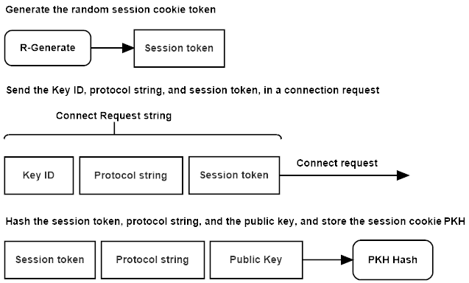

Figure 6.1: QSMP connection request.

The client initializes a key exchange operation, by sending the server a **connect request** packet. The packet message contains the client’s key identification array, a random session token, and the protocol configuration string. The client stores a hash of the random session token, the protocol string, and the asymmetric signatures schemes verification key in the session cookie *pkh* state value, for use later in the key exchange.

* 1. **Connect Response**

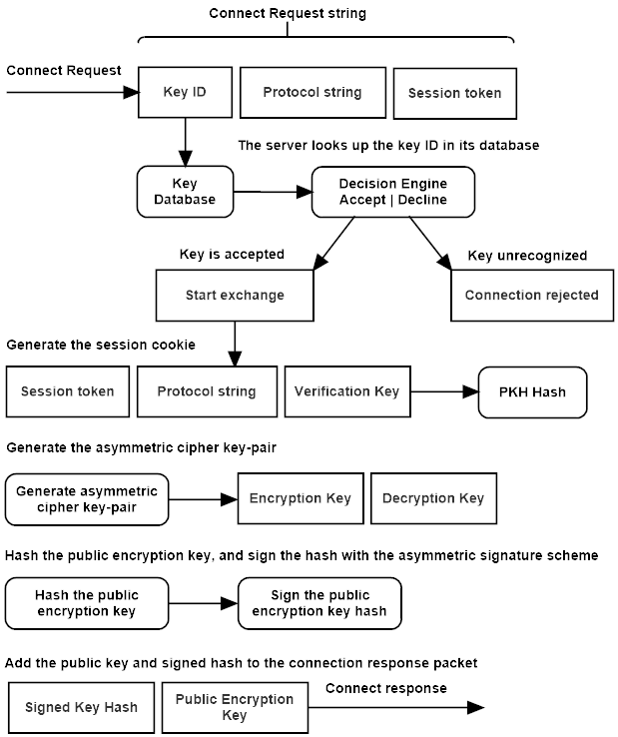

Figure 6.2: QSMP server connection response.

The server checks its database for a key matching the key identification array sent by the client in the **connect request** message. The server then compares the configuration string contained in the message against its own protocol string for a match. The server also verifies the key’s expiration time, and if all fields are valid, loads the key into state. If the protocol configuration strings do not match, the server will send an **unknown protocol** error to the client and close the connection. If the client’s key has expired, the server will send a **key expired** error message. If the key is not known to the server, the server sends a **key unrecognized** error message to the client. In any of these failures occur, the server closes the connection and logs the event, and the client is expected to close the connection, and pass the error up to the user interface software, that can initiate actions or inform the user of the cause of the failure.

The server hashes the key ID array, the client’s random session token, and its local copy of the asymmetric signature public verification key, and stores the hash in its session cookie state value *pkh*, for use as a unique session cookie.

The server generates a public/private asymmetric cipher key-pair. The server hashes the public key, and signs the hash with the asymmetric signature scheme’s private signing key. The client has a copy of the asymmetric signature verification key, that will be used to verify this signature. The server stores the private asymmetric cipher key temporarily in its state.

The server adds the public asymmetric encapsulation key, and the public keys signed hash, to the **connect response** message, and sends it to the client.

* 1. **Exstart Request**

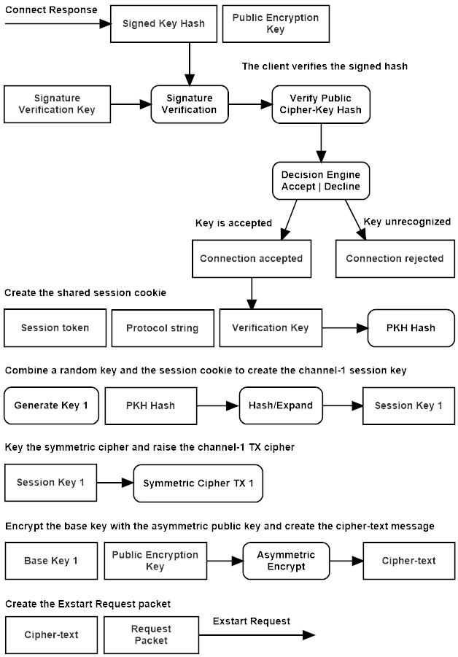

Figure 6.3: QSMP client exstart request.

The client uses the public signature verification key to check the signature on the asymmetric encapsulation key’s hash, that was sent along with the asymmetric ciphers encapsulation key in the **connect response** message. If the signature is verified, the asymmetric cipher’s key is hashed, and that hash is compared to the signed hash contained in the servers connect response message. If the signature verification fails, the client sends an **authentication failure** message and terminates the connection, likewise if the hash check fails, the client sends a **hash invalid** error message.

The client uses the asymmetric cipher key to encapsulate a base *shared secret*, producing a cipher-text that will be sent to the server, and used to generate a shared secret value.

This shared secret is combined with the session cookie, to initialize cSHAKE, which derives the symmetric ciphers key and nonce. This cipher is set to encrypt, and acts as the client’s transmit interface (TX) for the channel-1 communications stream.

The asymmetric cipher-text is added to the **exstart request** packet, and sent to the server.

* 1. **Exstart Response**

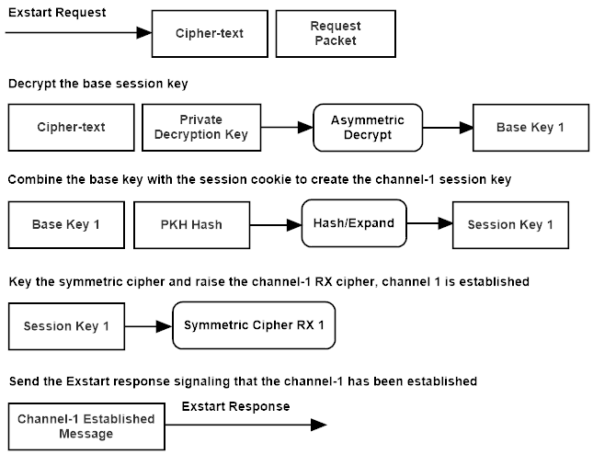

Figure 6.4: QSMP server exstart response.

The server decapsulates the cipher-text sent by the client in the **exstart request** packet, and extracts the base shared secret. This shared secret is combined with the session cookie, to initialize cSHAKE, which derives the symmetric cipher’s key and nonce. This cipher instance is set to decrypt and authenticate, and acts as the server’s receive interface (RX) for the channel-1 communications stream.

The server sets the first byte of the **exstart response** message to the **remote connected** flag, signaling to the client that the first channel of the bi-directional communications stream has been established, and sends the exstart response message to the client.

* 1. **Exchange Request**

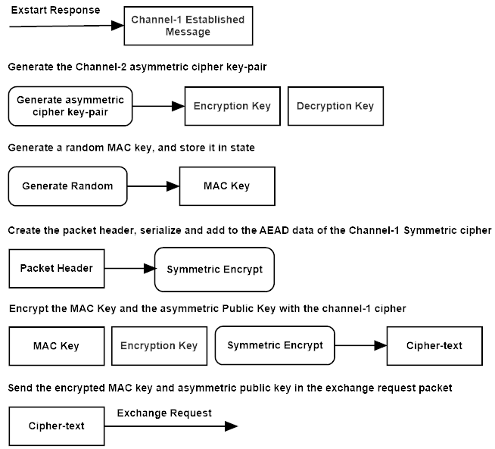

Figure 6.5: QSMP client exchange request.

The client checks the message flag of the **exstart request** packets message for the **remote connected** flag, if it is found the server generates an asymmetric cipher key-pair. The client stores the private key in state, and adds the public key to the **exchange request** message. The client generates a MAC key, stores it in state, and copies it to the exchange request message. The client serializes the exchange request packet header and adds it to the associated data of the channel-1 TX cipher. The client then encrypts the packet’s message with the channel-1 TX cipher.

The second key-exchange uses a symmetric authentication MAC key, sent to the server over the encrypted channel. That encrypted channel’s shared secretwas verified with the asymmetric signature scheme, establishing trust, and sending the MAC key over that encrypted channel, extends that authentication trust to the second asymmetric cipher key-exchange. Allowing the server to return a MAC authenticated asymmetric cipher-text over the unencrypted second channel, using the MAC function and secret key to authenticate the asymmetric cipher-text.

* 1. **Exchange Response**

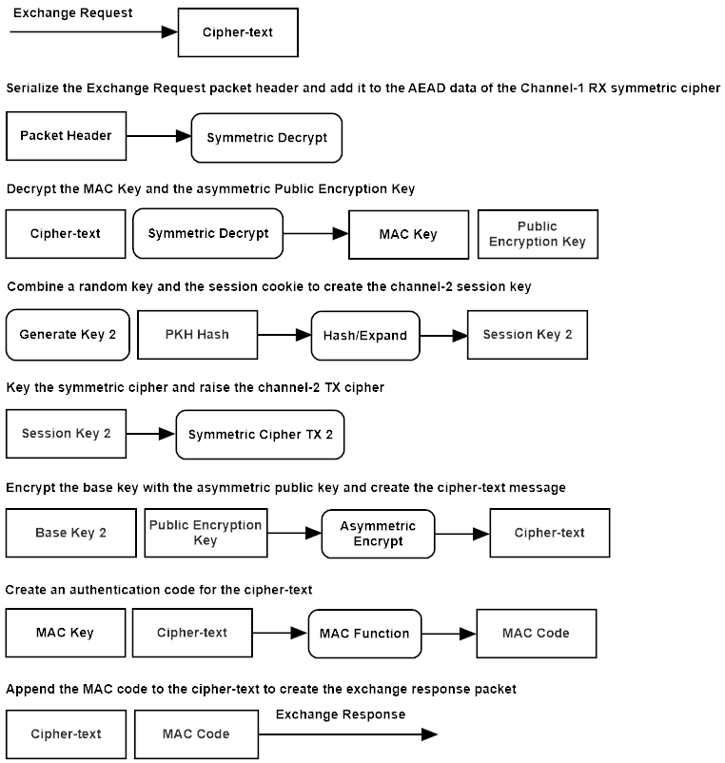

Figure 6.6: QSMP server exchange response.

The server serializes the exchange request packet header, and adds it to the associated data of the channel-1 RX cipher. The server authenticates and decrypts the **exchange request** message using the channel-1RX symmetric cipher, and extracts the asymmetric cipher public-key, and the MAC key. The server encapsulates a shared secret with the public asymmetric cipher-key, producing the second base shared secret, and the cipher-text which is added to the **exchange response** message. The MAC key contained in the exchange request, is used to MAC the asymmetric cipher-text, with the authentication code appended to the exchange response message.

The server combines the shared secret, and the session cookie *pkh*, to key cSHAKE and derive the key and nonce for the channel-2 symmetric cipher. The cipher is keyed and set to encrypt, raising the server’s transmit channel (TX) of the channel-2 communications stream. The server sends the asymmetric cipher-text and MAC authentication code to the client.

* 1. **Establish Request**

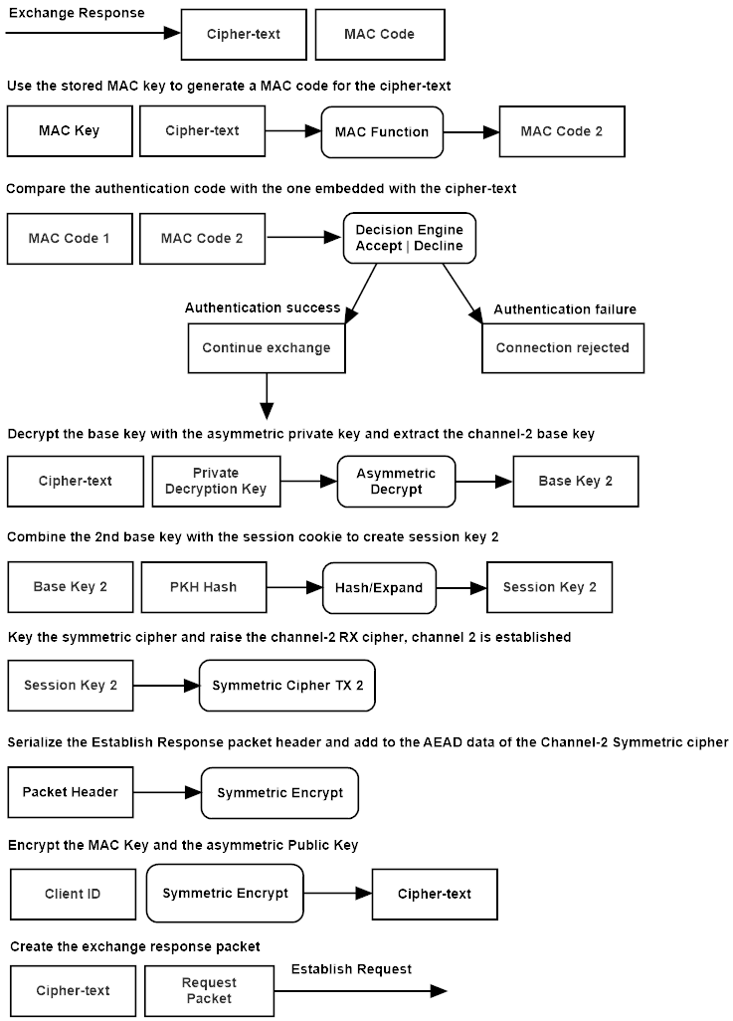

Figure 6.7: QSMP client establish request.

The client MACs the cipher-text in the **exchange response** message, using the key stored in state, and verifies the integrity of the cipher-text. The client then decapsulates the asymmetric cipher-text, and extracts the base shared secret. The shared secret is combined with the session cookie *pkh*, to key cSHAKE and derive the key and nonce for the channel-2 RX symmetric cipher. The symmetric cipher is keyed and set to authenticate and decrypt, raising the client’s receive channel on the channel-2 communications stream. Both communications channels are now initialized. The client serializes the **establish request** packet header, and adds it to the channel-1 TX cipher’s state, then encrypts a copy of its *key identity* string, adds the cipher-text to the establish request message, and sends the packet to the server to confirm the second channel has been raised.

* 1. **Establish Response**

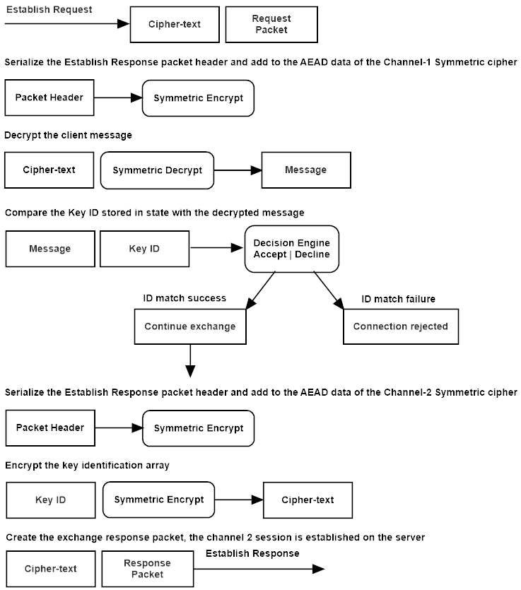

Figure 6.8: QSMP server establish response.

The server serializes the **establish request** packet header, and adds it to the associated data of the server’s channel-1 RX cipher, and then authenticates and decrypts the establish request message. The server compares the decrypted *key identification* array to the one it has stored in state. If the message is verified, the server sets the internal **session established** flag, and is ready to process data on both channels of the communications stream. The server serializes the **establish response** packet header and adds it to the channel-2 TX cipher, then encrypts the key identification array, and adds it to the establish response message.

* 1. **Establish Verify**

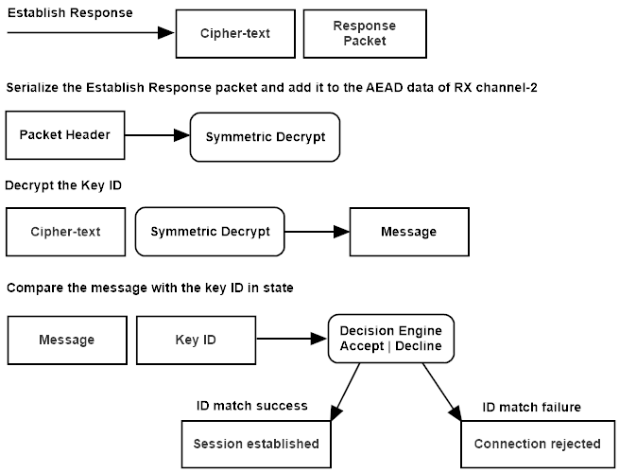

Figure 6.9: QSMP client verify.

The client adds the serialized packet header of the **establish response** to the associated data on its channel-2 RX cipher, and then authenticates and decrypts the message, and compares it to its key identification array in state. Upon successful decryption and verification of the message, the client now raises its session established flag, and is ready to process data.

# **Formal Description**

**Legend:**

**C** -The client host

**S** -The server host

**AKG** -The asymmetric cipher key generator function

**cng** -The protocol configuration string

**cprrx** -A receive channels symmetric cipher instance

**cprtx** -A transmit channels symmetric cipher instance

**cpt** -The symmetric ciphers cipher-text

**cpta** -The asymmetric ciphers cipher-text

**DAsk** -The asymmetric decapsulation function and public key

**EApk** -The asymmetric encapsulation function and secret key

**Dk** -The symmetric decapsulation function and key

**Ek** -The symmetric encapsulation function and key

**Exp** -The key expansion function: cSHAKE

**H** -The hash function: sha3

**kid** -The public keys unique identity array

**Mmk** -The MAC function and key: KMAC

**pek** -The public encapsulation key

**pekh** -The public asymmetric encapsulation key hash

**pkh** -The public key hash, a hash of the session token, the configuration string, and the public signature verification-key, used as the session cookie

**pvk** -The public signature verification key

**RBG** -The random bytes generator

**SAsk** -Sign with the secret signature key

**sec** -The shared secret derived from asymmetric encapsulation and decapsulation

**spkh** -The signed hash of the asymmetric public encapsulation-key

**stok** -A random string used as the session-token in the key exchange

**VApk** -Verify a signature the public signature key

**Key Exchange Sequence**

**7.1 Connect Request:**

The client first checks the expiration date on the public key, if the key is invalid, it queries the server for a new public verification key.

The client sends a connection request with its configuration string, key identity, and a random session token. The key identity (kid) is a multi-part 16-byte address and key identification array, used to identify the intended target server and corresponding key.

The client stores a hash of the session token, the configuration string, and the public asymmetric signature verification-key, which is used as a session cookie in the exchange.

**stok = RBG(n)**

**pkh = H(stok || cfg || pvk)**

The client sends the key identity string, session token, and the configuration string to the server.

**C{kid || stok || cfg }->S**

**7.2 Connect Response:**

The server responds with either an error message, or a response packet. Any error during the key exchange will generate an error-packet sent to the remote host, which will trigger a tear down of the connection on both sides.

The server first checks that it has the requested asymmetric signature key, using the key-identity array, then verifies that it has a compatible protocol configuration. The server stores a hash of the session token, the configuration string, and the public signature verification-key to create the public key hash, which is used as a session cookie.

**pkh = H(stok || cfg || psk)**

The server then generates an asymmetric encryption key-pair, stores the secret key, hashes the public encapsulation key, and then signs the hash of the public encapsulation key using the asymmetric signature key. The public signature verification key can itself be signed by a ‘chain of trust’ model, like PGP or X509, using a signature verification extension to this protocol.

**pk,sk = AKG(cfg)**

**pekh = H(pk)**

**spkh = Ssk(pekh)**

The server sends a response message containing a signed hash of the public asymmetric encapsulation-key, and a copy of that key.

**S{spkh || pk}->C**

**7.3 Exstart Request:**

The client verifies the signature of the public encapsulation keys hash, then generates its own hash of the public key, and compares it with the one contained in the message. If the hash matches, the client uses the public-key to encapsulate a shared secret.

**cph = VApk(H(pk)) = true ? cph : NULL**

**cpta = EApk(sec)**

The client then combines the shared secret and public key hash to key the derivation function, and uses the output to key the clients transmit-channel symmetric cipher.

**k,n = Exp(sec, pkh)**

**cprtx(k,n)**

The client transmits the asymmetric cipher-text to the server.

**C{cpta}->S**

**7.4 Exstart Response:**

The server decapsulates the shared-secret, combines it with the session cookie *pkh* to key the derivation function that generates the symmetric cipher key and nonce, it then keys the servers receive-channel cipher with the output session key. The channel-1 communications stream is now established.

**sec = DAsk(cpta)**

**k,n = Exp(sec, pkh)**

**cprrx(k,n)**

The server sends the client an established message for the first channel.

**S{m}->C**

**7.5 Exchange Request:**

The client generates and stores an asymmetric cipher key-pair. The client generates a MAC key and stores it to state. The server then encrypts the MAC key and the asymmetric encapsulation-key using the channel-1 communications stream, and sends the encrypted MAC and encapsulation keys to the server.

**pk,sk = AKG(cfg)**

**mk = RBG(n)**

**cpt = Ek(pk || mk)**

**C{cpt}->S**

**7.6 Exchange Response:**

The server decrypts the MAC and encapsulation keys, and uses the encapsulation-key to encapsulate a shared-secret for channel 2. The server then uses the MAC key received from the client, to MAC the asymmetric cipher-text, appending a MAC code to the message.

**mk,pk = Dk(cpt)**

**cpta = EApk(sec)**

The server then expands the shared secret and public key hash, and creates the symmetric ciphers key and nonce.

**k,n = Exp(sec,** **pkh)**

The MAC function is keyed with the MAC key sent by the client over the encrypted channel, the cipher-text is added to the MAC, and the output code is prepended to the message.

**cc = Mmk(cpta)**

The server’s channel-2 transmission channel is initialized, and the authenticated cipher-text is sent to the client.

**cprtx(k,n)**

**S{cc || cpta}->C**

**7.7 Establish Request:**

The client uses the stored MAC key to key the MAC function, then adds the cipher-text to the hash. The client compares the hash code appended to the cipher-text with the one generated with the MAC function before decapsulating the shared key.

**mc = Mmk(cpta) = true ? mc : NULL**

The client then decapsulates the shared secret, combines it with the public key hash, and expands it.

**sec = DAsk(cpta)**

**k,n = Exp(sec, pkh)**

The client then keys the clients receive channel, the second communications stream is established, and the client sends an established message. The established message is the key identity array, encrypted and sent to the client.

**cprrx(k,n)**

**cpt = Ek(kid)**

**C{cpt}->S**

**7.8 Establish Response:**

The server authenticates and decrypts the message, then compares it to its copy of the key id.

**kid = Dk(cpt)**

The server re-encrypts the key identity array, using the channel-2 cipher, and sends it to the client for verification. Both channels of the server’s communications stream are now initialized.

**cpt = Ek(kid)**

**S{cpt}->C**

**7.8 Establish Verify:**

The client authenticates and decrypts the message, then compares it to its copy of the key identification array.

**kid = Dk(cpt)**

Both of the client’s communications stream channels are now established, the connection is now ready to send and receive data.

**7.9 Transmission:**

The host, client or server, transmitting a message, first serializes the packet header and adds it to the symmetric ciphers associated data parameter. The host then encrypts the message, updates the MAC function with the cipher-text, and appends a MAC code to the end of the cipher-text.

The serialized packet header, including the message size, protocol flag, and sequence number, is added to the MAC state through the additional-data parameter of the authenticated stream cipher RCS. This unique data is added to the MAC function with every packet, along with the encrypted cipher-text.

**(cpt || mc) = Ek(sh, m)**

The packet is decrypted by serializing the packet header and adding it to the MAC state, then finalizing the MAC on the cipher-text and comparing the output code with the code appended to the cipher-text. If the code matches, the cipher-text is decrypted, and the message passed up to the application.

**m = Dk(sh, cpt) = true ? m : NULL**

# **Design Decisions**

QSMP is built upon the Transport Control Protocol (TCP) in the accompanying example code, but networking protocol choices should be considered as operating at a layer beneath the QSMP protocol. QSMP is an authenticated key exchange and secure communication protocol, it may use TCP, UDP, or a custom IP stack to transport packets. Future revisions of the protocol implementation may use a custom IP stack, implement windowing controls, packet buffers, and other custom networking controls as best suits implementation-specific requirements. However, many widely used VPN software implementations currently use TCP, and forego the complexities of a custom-built IP stack, and keeping the implementation relatively simple and straight-forward was a chief goal of the example project, to lend clarity to a somewhat complex network security protocol. Future implementation will likely introduce a more complex networking implementation, one that offers more granularity in the network application of the QSMP protocol.

QSMP does not currently use protocol negotiation, this is for several reasons. Though trivial to implement, and that QSMP currently has several implementation choices, protocol negotiation is too often misused to ‘dumb down’ a security scheme to the cheapest possible combination of security protocols. It also adds extra messaging overhead for the protocol negotiation. QSMP currently supports three asymmetric configurations: Dilithium-Kyber, Dilithium-NTRU, and McEliece-Sphincs+. More parameter sets will be added in the future, and other asymmetric primitives like Falcon may also be added, but the benefit of adding protocol negotiation is limited, and not necessary in most of the intended implementation use-cases.

QSMP does not implement signature chaining directly, but this is a feature that can either be added, or implemented using a secondary protocol implementation like X509. It is not though, a feature of the design, as QSMP is primarily as a standalone secure communications protocol. We do believe that in cases where this extra layer of authentication is warranted by the implementation, that signature chaining can be a means to add some extra assurance to the key-exchange authentication. Public keys can be distributed in X509 format, and the authentication chain checked in an extra step, with the primary public key extracted and passed to the QSMP client.

QSMP packet headers were designed to be compact, less than half the size of the standard SSH-2 protocol at just 13 bytes. Unnecessary fields are omitted, and integer sizes are kept within ranges of reasonable expected use, such as flags taking up just a single byte, and the message data size parameter a 32-bit integer. In a custom IP stack implementation, this can translate to a small overall packet header size, making applications of the protocol that send small amounts of data in ‘real time’ processing applications such as Telnet, more efficient. An application should never require more than 255 flags, and a payload size should never exceed 4 gigabytes of message data in a single packet payload, so we feel these are more conservative and realistic uses of packet header space.

We use a 2-channel communications system, with each channel keyed separately, this is to fulfill the purpose of what this protocol represents; a high-security, post-quantum, communications protocol. Other VPN implementations use a single shared secret, derived to key transmit and receive symmetric ciphers on both sides of the communications stream. They take security ‘shortcuts’, preferring small gains in performance over the overall security of the design. We feel that in order to be truly secure, each host, client and server, must generate the key for the channel that they transmit data over, anything less is a compromise to the security in the design. Further, we use two independent authenticated key exchanges, using post-quantum asymmetric ciphers to encapsulate two unique shared secrets. We are well aware of ‘shortcuts’ used by other protocols that could reduce this to a single asymmetric key exchange, but do not feel that this offers the best possible security guarantee, and the goal of QSMP, is to provide strong, uncompromising security to a communications stream.

We use a post-quantum authenticated stream cipher; RCS. This cipher’s transform is based on the wide-block form of the Rijndael cipher (AES), with a hash-based key schedule and strong authentication using KMAC. We believe authenticated stream ciphers are the future of symmetric ciphers, and that this cipher which uses cSHAKE to generate round keys, KMAC for authentication, and increased transformation rounds from 14 with AES, to 22 with RCS, provides a realistic post-quantum symmetric security. There are those that would urge us to use AES or ChaCha for another twenty years, until it is proven beyond doubt that they have been broken, but we do not think this is wise, as the powerful agencies that work relentlessly towards breaking the worlds cryptography, do not publish those discoveries in scientific journals, so we choose to use stronger primitives now as a precaution, and a better guarantee of true long-term security in the coming quantum age.

QSMP was designed to be secure, not just in the present day, but in a future which promises incredible advances in computing technology, advances that can not now be fully known, and must not be underestimated. It is designed for the purpose of keeping sensitive data safe, now and for decades to come.